Applied Microeconomics — Week 4
Redistribution and social security
_Summary of Lecture 4 (Delfgaauw), Public Economics. Slide numbers in brackets. Figures redrawn; the numerical example uses the lecture's own numbers (w = 15, T = 720, G = 450, t = 0.1)._

The shape of the lecture
Part | Question it answers
1. Facts | How unequal is the world, and how much do governments redistribute?
2. Why redistribute? | The normative case: social welfare functions
3. Why government? | Market failure in the 'market for redistribution'
4. Efficiency effects | What redistribution costs, and why (the exam core)

1. Facts and figures
- Extreme poverty has collapsed globally over 200 years, and this is not only about money: life expectancy, infant mortality, literacy and child labour all improved dramatically.
- Global income inequality is declining but still huge; the wealth distribution is even more unequal, with a growing share for the top 0.1%.
- Measurement is hard [10]: individuals or households? before or after taxes and benefits? in-kind benefits are often missed ('profijt van de overheid'), and wealth data are less reliable than income data.
- Netherlands over time [14]: social security spending was 11.6% of GDP in 1963, 20% in 1983, 10.7% in 2000, 12% in 2023. The old-age dependency ratio rose from 0.24 in 2000 to 0.35 in 2020. Drivers are volume (number of programs, eligibility) and price (indexation).

2. Why redistribute?
A purely self-interested rich individual would prefer no redistribution. The case is normative: society prefers a distribution different from the one the market produces, expressed through a social welfare function W = F(U₁, ..., U_{n}).

The utilitarian benchmark slides 18–20
Take the additive (Bentham) welfare function and three assumptions:
- W = U₁ + U₂ + ... + U_{n}
- utility depends only on income
- diminishing marginal utility of income: U' > 0 and U'' < 0
- total income is fixed
Maximising W subject to a fixed total income gives the condition:
MU₁(I₁) = MU₂(I₂) = ... = MU_{n}(I_{n})
The Peter and Paul diagram [19] shows why: if Paul's marginal utility exceeds Peter's, moving a euro from Peter to Paul raises total welfare, because Paul gains more than Peter loses. Keep going until the marginal utilities are equal.
Equal marginal utilities implies complete equality ONLY IF you add the assumption that everyone has the same utility function. That extra assumption is doing all the work, and it is the one most open to challenge.

Other theories of justice slide 21
Theory | What it maximises or requires
Utilitarian (Bentham) | the sum of utilities: W = U1 + ... + Un
Rawls | the worst-off person: W = min(U1, ..., Un), argued from behind a 'veil of ignorance'
Egalitarianism | equality of outcomes
Capabilities (Sen) | what people are actually able to do and be, not just income
Libertarianism | just processes and property rights, not patterns of outcomes

Complications [22]: what if people differ in their preferences, for example between income and leisure? And should we compensate differences in outcomes that come from effort, from innate ability, from birthplace, or from inherited wealth? Bad luck is the easy case; the rest are contested.

3. Why does the government do it?
Private redistribution does exist — charities, religious communities, families — motivated by altruism: U₁ = F[I₁, U₂(I₂)]. If I care about your utility, transferring to you can be a Pareto improvement. So why is most redistribution public? Apply the market-failure framework from earlier weeks.
- The welfare state is a public good. The rich also benefit from less poverty, but each one prefers to free-ride on others' donations, so private giving is under-provided. Government can enforce contributions.
- Scale effects: defining who is poor, and administering transfers, is cheaper once.
- Externalities of poverty: effects on the well-being of others and spill-over effects such as crime.
- Incomplete information: people may be too optimistic about their own risk of becoming poor.
- Paternalism.
- Redistribution as poverty insurance: private poverty insurance fails because of asymmetric information — severe moral hazard and adverse selection. Government can impose fines for fraud, job-search requirements, and mandatory participation.
But: government failure is real too. The mechanisms that fix market failure bring their own distortions, which is the subject of the rest of the lecture.

4. Efficiency effects
If the second fundamental theorem held, we could separate efficiency from redistribution: fix the distribution with lump-sum transfers, then let markets do their work. In practice redistribution changes behaviour, so the separation breaks down. The lecture lists four issues.

(1) Cash versus in-kind slide 28
The poor sometimes receive goods rather than cash. In-kind transfers are generally less efficient, because the recipient could have reached higher utility by spending the same money how they chose (Figures 12.3 and 12.4 in the book). The main motivation is paternalism.

(2) Crowding out slide 29
Public redistribution reduces the incentive for private redistribution:
- Private charity falls when the state transfers, because donors care about the recipient's total income and free-ride on public provision.
- Private saving falls when public social security insures old age and bad times. In Rosen's two-period model the crowding out can be one-for-one, with consumption unchanged.
Van Prinsterer made exactly this argument in 1851: state poor relief 'gives church and private charity a sleeping draught' and so destroys voluntary charity.
Crowding out can be seen as a type of moral hazard: public insurance reduces private self-protection. Note the counter-arguments — crowding out is partial rather than complete, and private charity was under-provided to begin with because of free riding.

(3) Can redistribution improve efficiency? slide 30
- Better nutrition can raise productivity.
- Recent work (Mullainathan and co-authors) shows poverty causally reduces the quality of decision-making.
- How inequality as such affects efficiency is an open question.
Normative prescription: any policy that improves both distribution and efficiency should simply be adopted.

(4) Effect on labour supply slides 31–39 — the exam core
Anti-poverty programs are means-tested: eligibility depends on income. At some point benefits must fall as income rises, and that is economically identical to a tax on income. This is where assumption 3 from slide 17, that total income is fixed, gets relaxed.

The set-up
- Utility U(y, L) rises in income y and leisure L.
- Wage w, total time T, so earnings E = w(T - L).
- Without redistribution, y = E.
A basic welfare program has two parameters: a grant G received when earnings are zero, and a withdrawal rate t at which the grant is reduced per euro earned.
B = G - tE the benefit actually received
B = 0 once E >= G/t the break-even point
y = E + B = G + (1 - t)E total income
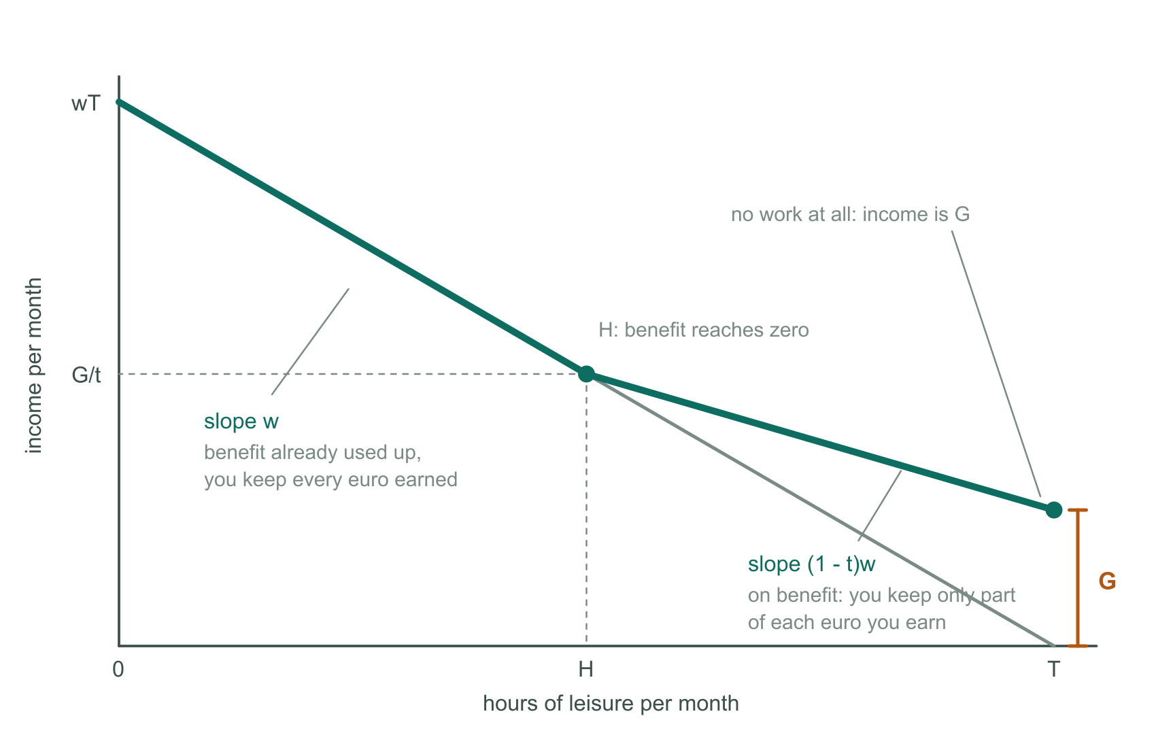
The program lifts the right-hand end of the budget line by G and flattens its slope from w to (1 - t)w. The kink H is where the benefit runs out.
Reading the diagram:
Label | Meaning
T | all time taken as leisure — no work at all
wT | all time worked — maximum possible earnings
G | the lift at the right-hand end: income when you earn nothing
slope w | without the program you keep the whole wage
slope (1-t)w | on benefit you keep only (1 - t) of each euro earned
H | the leisure level at which the benefit reaches zero: H = T - G/(tw)
G/t | the income at that point, since the benefit is zero there

Left of H the benefit is already zero and cannot go negative, so the line returns to slope w and lies on top of the original line. People earning more than G/t are untouched by the program.

Why work falls
- Income effect: you are better off at every low level of work, and leisure is a normal good.
- Substitution effect: an hour of work now pays (1 - t)w instead of w, so leisure is cheaper.
Unusually, both effects point the same way, so the prediction is unambiguous: hours of work fall.
The efficiency problem: at the new choice the individual's marginal value of leisure is (1 - t)w, while marginal productivity is still w [slide 36]. That wedge is the source of the deadweight loss. At the original optimum, without the program, MRS = w and the outcome is efficient [slide 35].

The numerical example
Wage w = 15, total hours T = 720, so the budget line is y = 10800 - 15L. Utility is quasi-linear, U = Y + 9000 ln L, which makes utility differences readable directly in euros. The program has G = 450 and t = 0.1, so the benefit runs out at earnings of 450/0.1 = 4500, i.e. 300 hours of work, i.e. L = 420. The new budget line is y = 10170 - 13.5L.
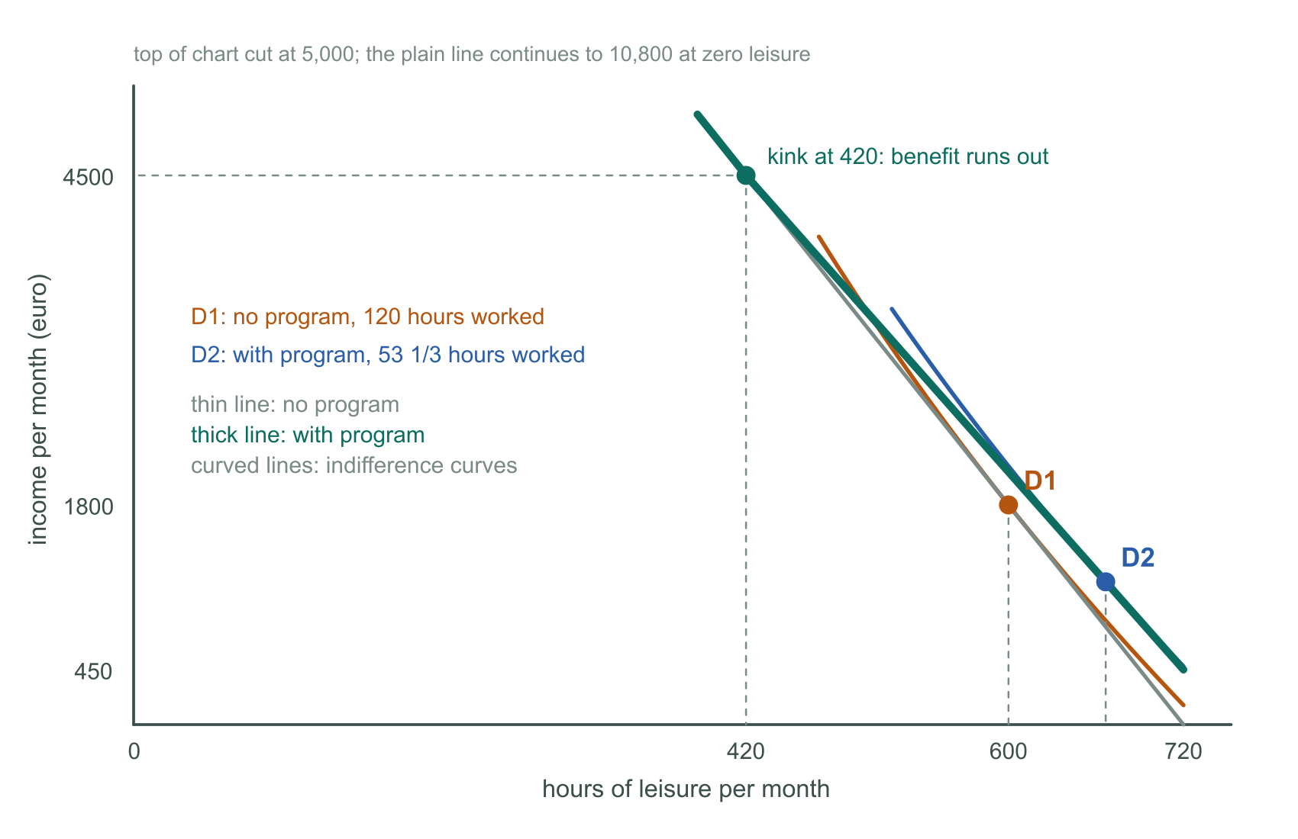
D1 is the optimum without the program (120 hours of work); D2 is the optimum with it (53 1/3 hours). The thick line is the budget constraint under the program.
 | Hours worked | Earnings | Income | Utility
No program | 120 | 1800 | 1800 | 59,372.4
With the program | 53 1/3 | 800 | 1170 (incl. 370 benefit) | 59,690.6
Same 370 as a lump sum | 120 | 1800 | 2170 | 59,742.4

He works less than half as much, and he is better off — the program does help him. But the third row is the punchline: hand over the same 370 with no strings and he is better off still, at identical cost to the government.

Where the deadweight loss comes from
Transfers are not losses: the 370 he receives and the 80 clawed back both simply change hands. What is destroyed is production that never happens.
hours no longer worked = 66 2/3 -> output lost = 66 2/3 x 15 = 1000
value of the extra leisure he gains = 948.20
deadweight loss = 1000 - 948.20 = 51.80 per month
Equivalently, as a leaky bucket: the government spends 370, he gains the equivalent of 318.20, and 51.80 evaporates. Or as the familiar triangle: 66 2/3 hours lost times the wedge tw = 1.50, halved, is about 50.
Why the lump sum leaks nothing: it does not change his take-home wage, so he still works 120 hours, no output disappears, and the money simply moves. That is the practical meaning of a lump-sum transfer in the second fundamental theorem.

The extreme case t = 1
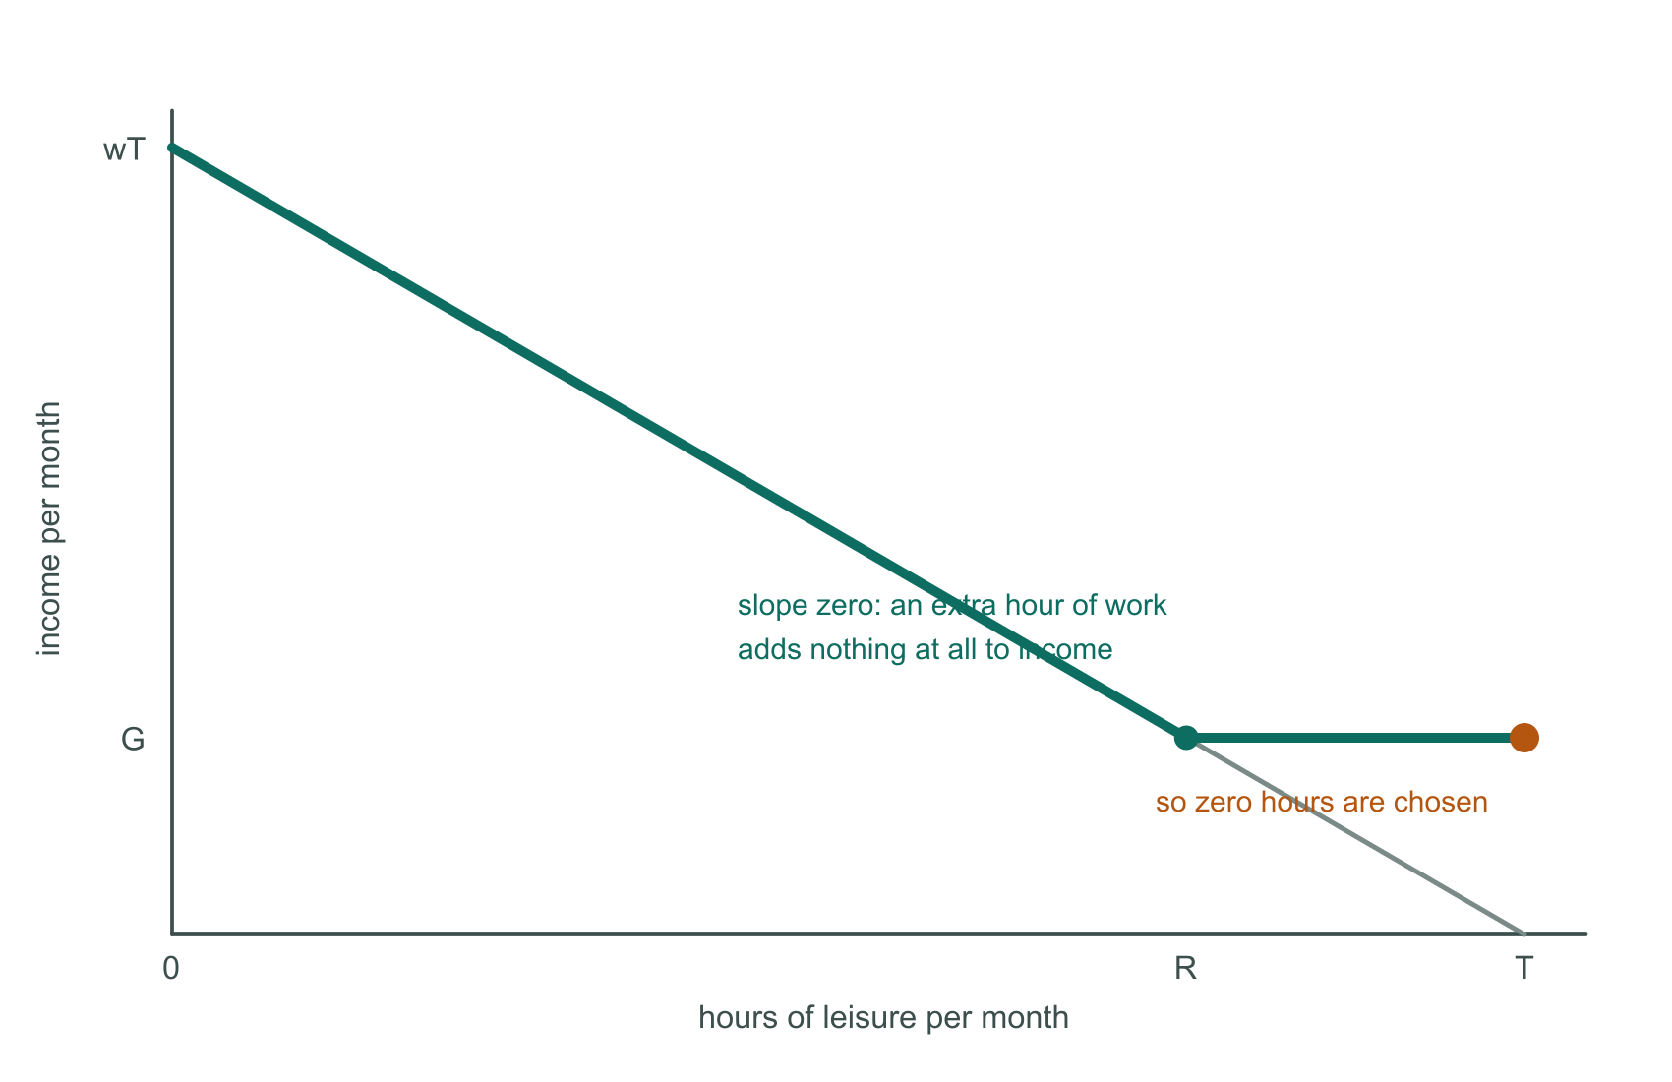
With a full clawback the budget line is horizontal up to R: an extra hour of work adds nothing at all, so zero hours are chosen. This is the poverty trap.

How big is the effect really?
The size of the efficiency cost depends on how strongly people respond to the substitution effect — the labour supply elasticity. That is an empirical question, not something theory settles.

5. The EITC
The Earned Income Tax Credit subsidises earnings through the income tax, so low-income workers face negative taxes. It is aimed at the working poor.
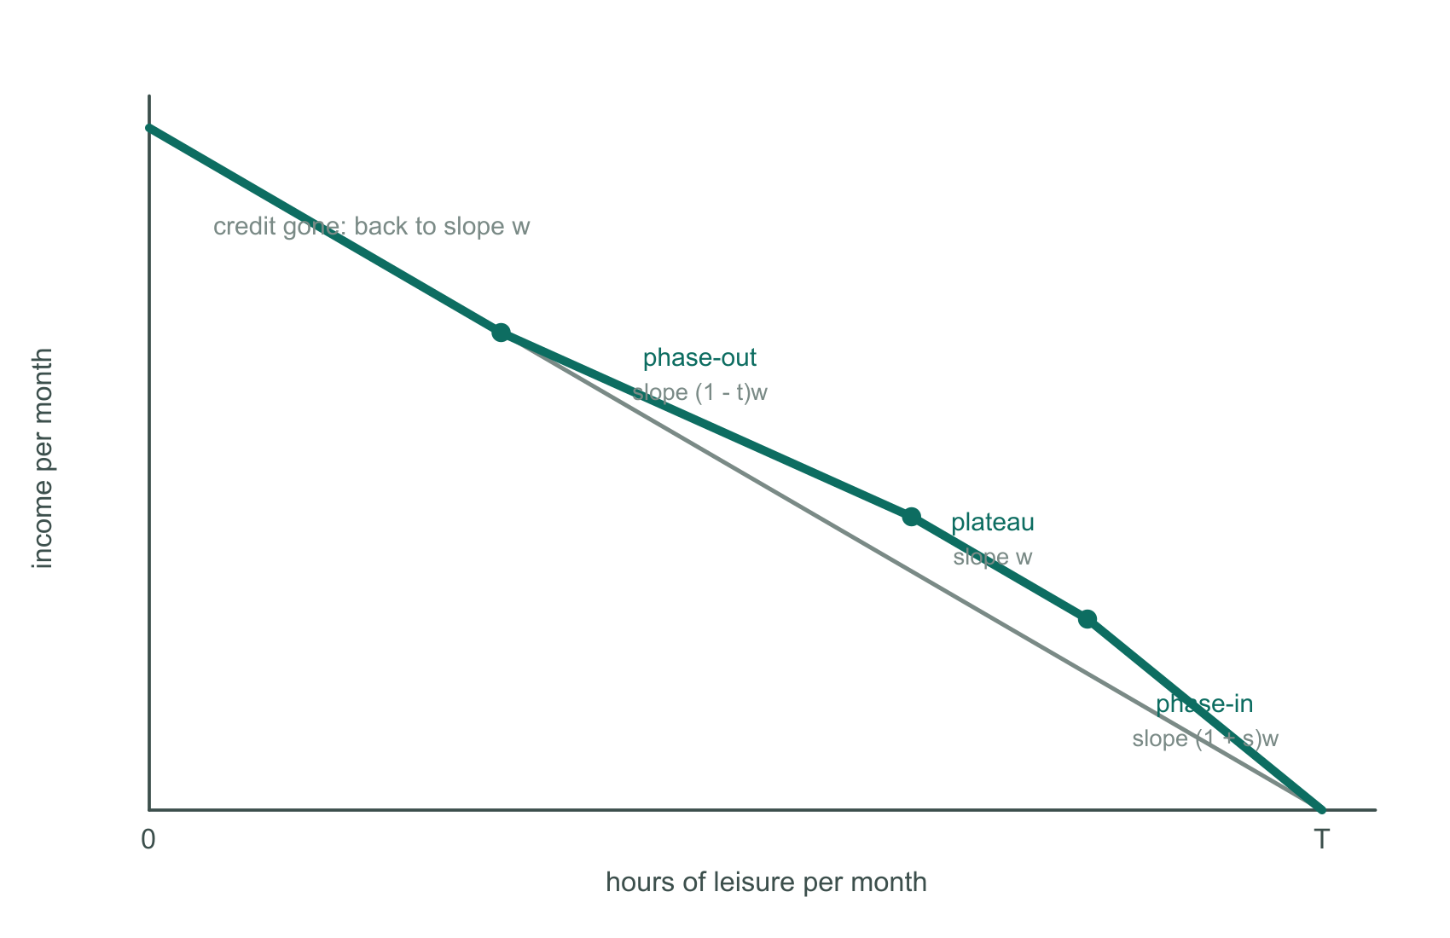
The EITC has three ranges: a phase-in where the subsidy makes the line steeper, a plateau, and a phase-out where withdrawal makes it flatter.
- Phase-in range: the subsidy is a negative marginal tax rate, so the slope is steeper than w and there is a stronger incentive to earn.
- Plateau: the credit is constant, so the slope is back to w.
- Phase-out range: the credit is withdrawn, giving a high marginal tax rate and the same disincentive as an ordinary means-tested benefit.

6. Conclusions
- Redistribution arises when society dislikes the distribution the market generates.
- Market failure in redistribution: poverty externalities, the welfare state as a public good, and asymmetric information in 'poverty insurance'.
- Anti-poverty programs are mostly means-tested, which weakens the incentive to earn.
- Hence a trade-off between redistribution and efficiency.
Why this matters beyond this lecture [54]: in an ideal world the second fundamental theorem lets you separate redistribution from efficiency policy. In practice redistribution is costly, so the distributional effects of policies aimed at efficiency matter in their own right — a tax on fossil fuels, investment in public transport, subsidising higher education.
Next weeks [55]: taxation. Incidence (who really bears the burden), efficiency (excess burden at the individual and market level), and optimal taxation in week 6.

Formula sheet
Concept | Formula | Note
Earnings | E = w(T - L) | L is leisure
Benefit | B = G - tE | zero once E >= G/t
Income with program | y = G + (1 - t)E | the budget constraint
Slope on benefit | (1 - t)w | what you keep per hour
Break-even earnings | E = G/t | income there is also G/t
Break-even leisure | H = T - G/(tw) | the kink
Efficient choice | MRS = w | no program
Distorted choice | MRS = (1 - t)w | with the taper
Optimal redistribution | MU1(I1) = ... = MUn(In) | additive SWF, fixed total income

Exam checklist
- Know which market failures justify public redistribution, and be able to name them: public good plus free riding, poverty externalities, asymmetric information in poverty insurance, paternalism.
- Be able to draw the budget constraint with G and t, label T, wT, G, H and G/t, and explain both slopes.
- Derive H = T - G/(tw) and the break-even income G/t rather than memorising them.
- Explain why both income and substitution effects reduce hours worked here.
- State the inefficiency precisely: MRS = (1 - t)w for the individual while marginal productivity is w.
- Be able to compare a means-tested transfer with a lump-sum transfer of the same cost, and say why only the first has a deadweight loss.
- Remember the policy trilemma: a generous G, a low t and a low budget cost cannot all hold, because the break-even point is G/t.
- For the EITC, distinguish the phase-in (negative marginal tax rate, stronger incentive) from the phase-out (high marginal tax rate).

